Computer Networking Commands

**Ping** :

The ping command is a networking utility used to test the reachability of a host on an Internet Protocol (IP) network. It can be used to determine whether a specific IP address is accessible, and also measures the round-trip time for messages sent from the [localhost](https://www.practicallynetworked.com/127-0-0-1-ip-address/) to a remote host. In addition, Ping can provide information about the network routes and the amount of time required to traverse them.

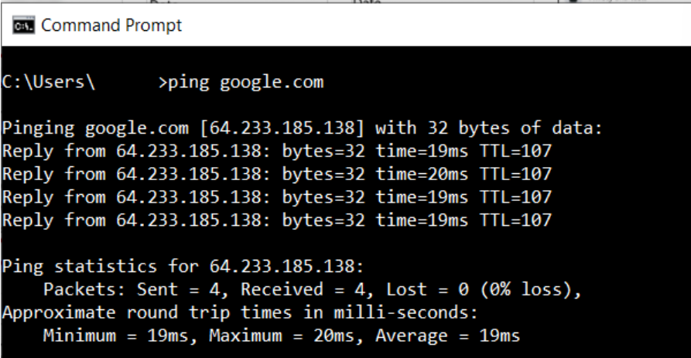

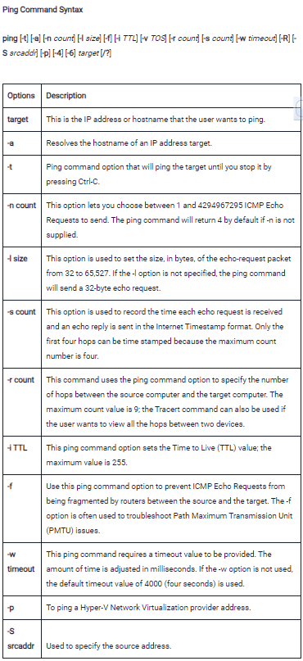**NetStat**  : NetStat is a networking utility that can be used to display all active network connections and their status. It can be used to identify which applications are using which ports and can be helpful in troubleshooting networking issues.

a Common TCP – IP networking command-line method.

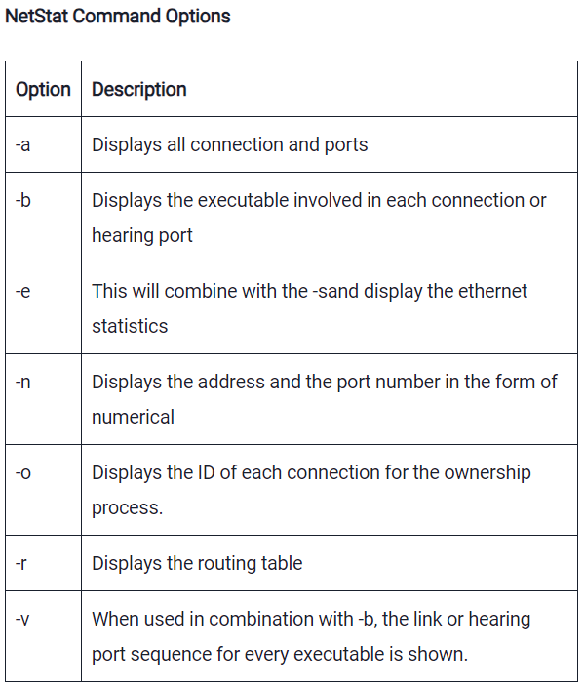

### SystemInfo : The SystemInfo command is used to retrieve detailed information about the hardware and software configuration of a Windows-based computer. When you run the SystemInfo command in a command prompt, it will display a comprehensive report containing information. It will display the operating system version, system manufacturer, processor details, memory size, network adapter details, and more. This command is helpful for system administrators and users to gather system-related information and diagnose issues.

**NbtStat** : NbtStat is a networking utility in Windows that helps users troubleshoot NetBIOS over TCP/IP problems. It can be used to display a variety of information about the current state of the NetBIOS over TCP/IP protocol on both local and remote computers.

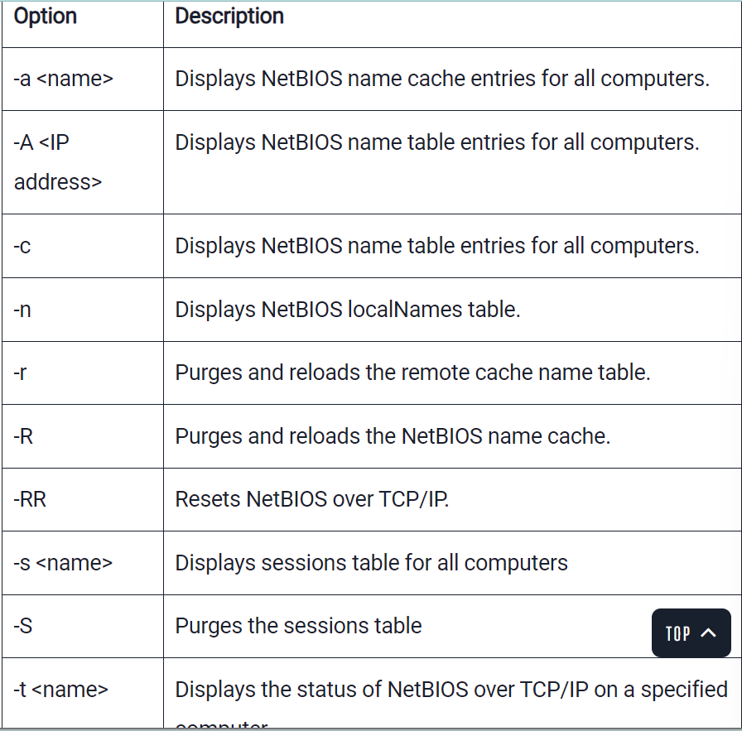

**Ip Config :** IP Config is a command-line tool that is used to display the current IP address configuration of a Windows machine. This includes the IP address, subnet mask, and default gateway. Additionally, IP Config can be used to release and [renew DHCP leases](https://www.practicallynetworked.com/what-does-renew-lease-on-wifi-mean/).

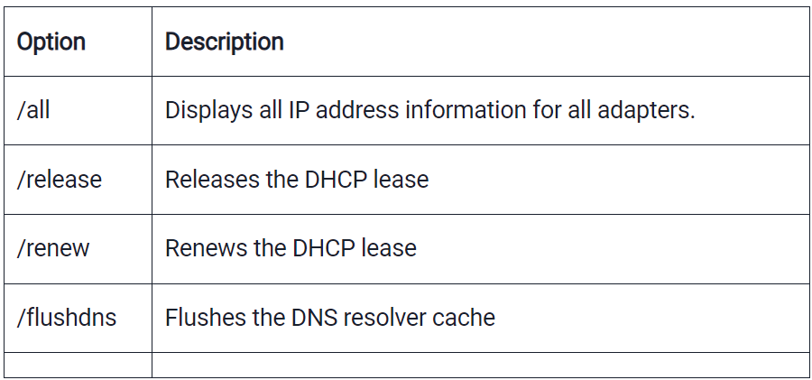

### Hostname : **How to Find Out Your Computer’s Name**

**ARP** : Address Resolution Protocol, is a networking utility used for mapping network addresses to physical addresses(MAC).

Arp -a -N 192.168.42.171

**Nslookup** : Nslookup is a command-line networking tool used for querying Domain Name System (DNS) to obtain domain name or IP address mapping, or other DNS records. Nslookup has two modes: interactive and non-interactive.

to find the IP address of www.example.com, you would type:

nslookup www.example.com

**Tracert**  : The tracert command is a Command Prompt command that displays the network packets being sent and received, as well as the number of hops required for them to reach their destination. The **tracert** command prints the path. If all routers on the path are functional, this command prints the full path. If a router is down on the path, this command prints the path up to the last operational router.

tracert *Destination Name or IP address(www.google.co.in)*

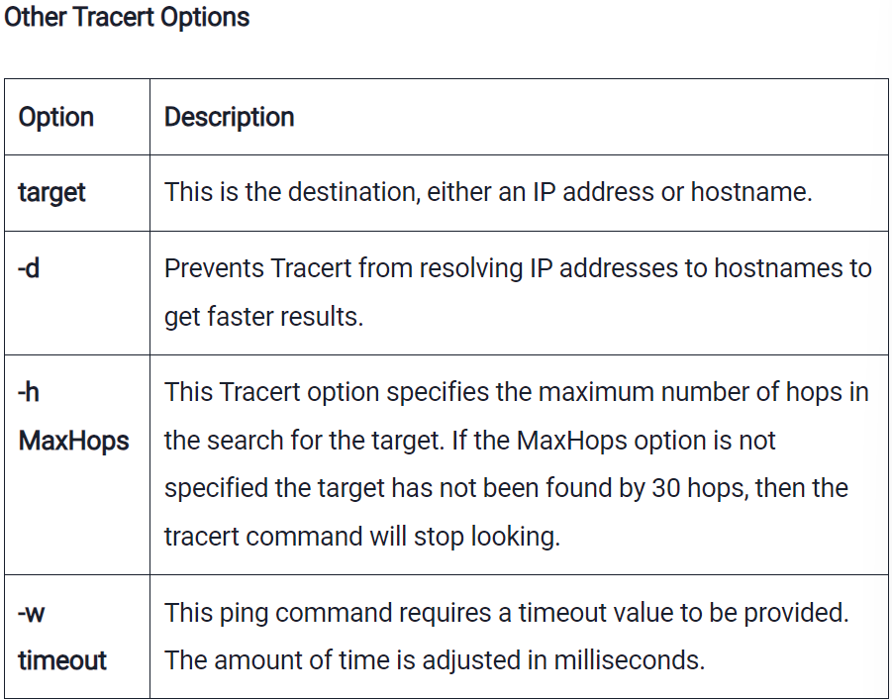

### PathPing : PathPing commands have a lot of similarities with Tracert. The pathping command combines the finest features of Tracert and Ping into one command.

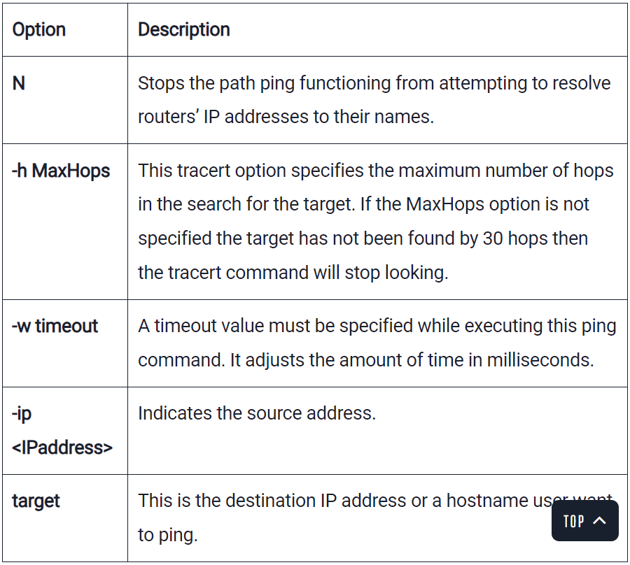

### GetMac : The MAC address is a unique identifier for every network capable device on the internet. The number is assigned during the manufacturing process and is stored in the device’s hardware.

### Don’t share it randomly.

### Route : The Route networking command is one of the most essential networking commands for Windows administrators. This command can be used to view and modify the network routing table. The route command can also be used to add or remove static routes from the routing table.

To view the current routing table, use the following syntax:

***route print***

To add a static route to the network routing table, use the following syntax:

route add <destination> mask <subnet mask> <gateway>

To remove a static route from the networking routing table, use the following syntax:

***route delete <destination>***

### NetDiag : NetDiag is a networking diagnostic tool that is included with the Windows operating system. This command-line utility can be used to troubleshoot various networking issues, such as connectivity problems or DNS resolution issues.

### To use the NetDiag utility, simply open a Command Prompt window and type “netdiag” followed by any desired options. Some useful options include “/debug” which will provide detailed output, and “/fix” which will attempt to automatically fix any identified networking problems.

### NET : Displaying available Net switches.

### NETSH : Displaying and configuring network adapters.

### Netsh is another very powerful command, allowing you to view and configure almost all of the network adapters in your device in much greater detail compared with some other commands.

### TASKKILL : Ending processes

**Questions** :

## **How can I see the computers and devices connected to my network using CMD?**

In some cases, you might want to see what computers and devices are connected to the same network as you are. One of the easy and friendly ways to do that is to use the **net view** command. Launch Command Prompt and run

**net view**

After a while, you should see a list of the computers and devices in your network.

## **How to check the network traffic in Windows’ command line**

Windows allows you to see the network traffic easily in the Task Manager. However, that’s a visual tool, and some users might want to get network utilization from the command line. Fortunately, there’s a command for that too. It’s called **typeperf** and lets you check the network traffic from CMD, although not in a friendly manner. Here’s the full command with arguments that you must run in Command Prompt:

**typeperf “\Network Interface(*)\Bytes Total/sec”**

**TIP:** The **typeperf** command can be used for gathering other types of

network information too. Here are other useful variations of it with different counters you can monitor:

**typeperf “\Network Interface(*)\Current Bandwidth**

**typeperf “\Network Interface(*)\Bytes Received/sec**

**typeperf “\Network Interface(*)\Bytes Sent/sec**

**typeperf “\Network Interface(*)\Packets/sec**

**typeperf “\Network Interface(*)\Packets Received/sec**

**typeperf “\Network Interface(*)\Packets Sent/sec**

For more info :

[homenetworkgeek](https://homenetworkgeek.com/15-useful-windows-networking-commands-you-should-know/)

[practicallynetworked](https://www.practicallynetworked.com/networking-commands/)

Youtube :

[Simplilearn](https://www.youtube.com/watch?v=bxFwpm4IobU)

[SheshChauhan](https://www.youtube.com/watch?v=AegRx0EzHmU)

[ServerGyan](https://www.youtube.com/watch?v=t3gXEk3789s) **

[NaturalSnaps](https://www.youtube.com/watch?v=nH85pddWWAk) **